There is an even split of concern between the environment and rising temperatures. 60% of those people felt like investment in renewables and restrictions on power/fuel usage was needed.

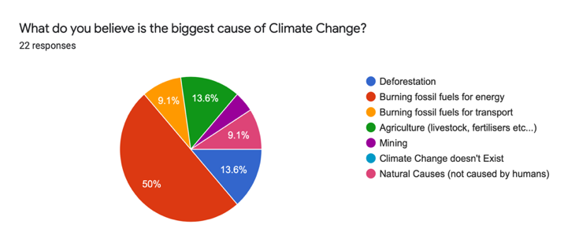

World CO2 emissions are rising

Climate Change

Global CO2 are on the rise, this seems to relate to the steady decline of rain occurring in the Melbourne.

100%

of people surveyed think climate change is real!

People feel that investment in renewable energy is the best way to combat climate change. With only 1 vote for recycling and 1 for nothing, this highlights that the community is overall informed about what causes climate change.

People feel that investment in renewable energy is the best way to combat climate change. With only 1 vote for recycling and 1 for nothing, this highlights that the community is overall informed about what causes climate change.